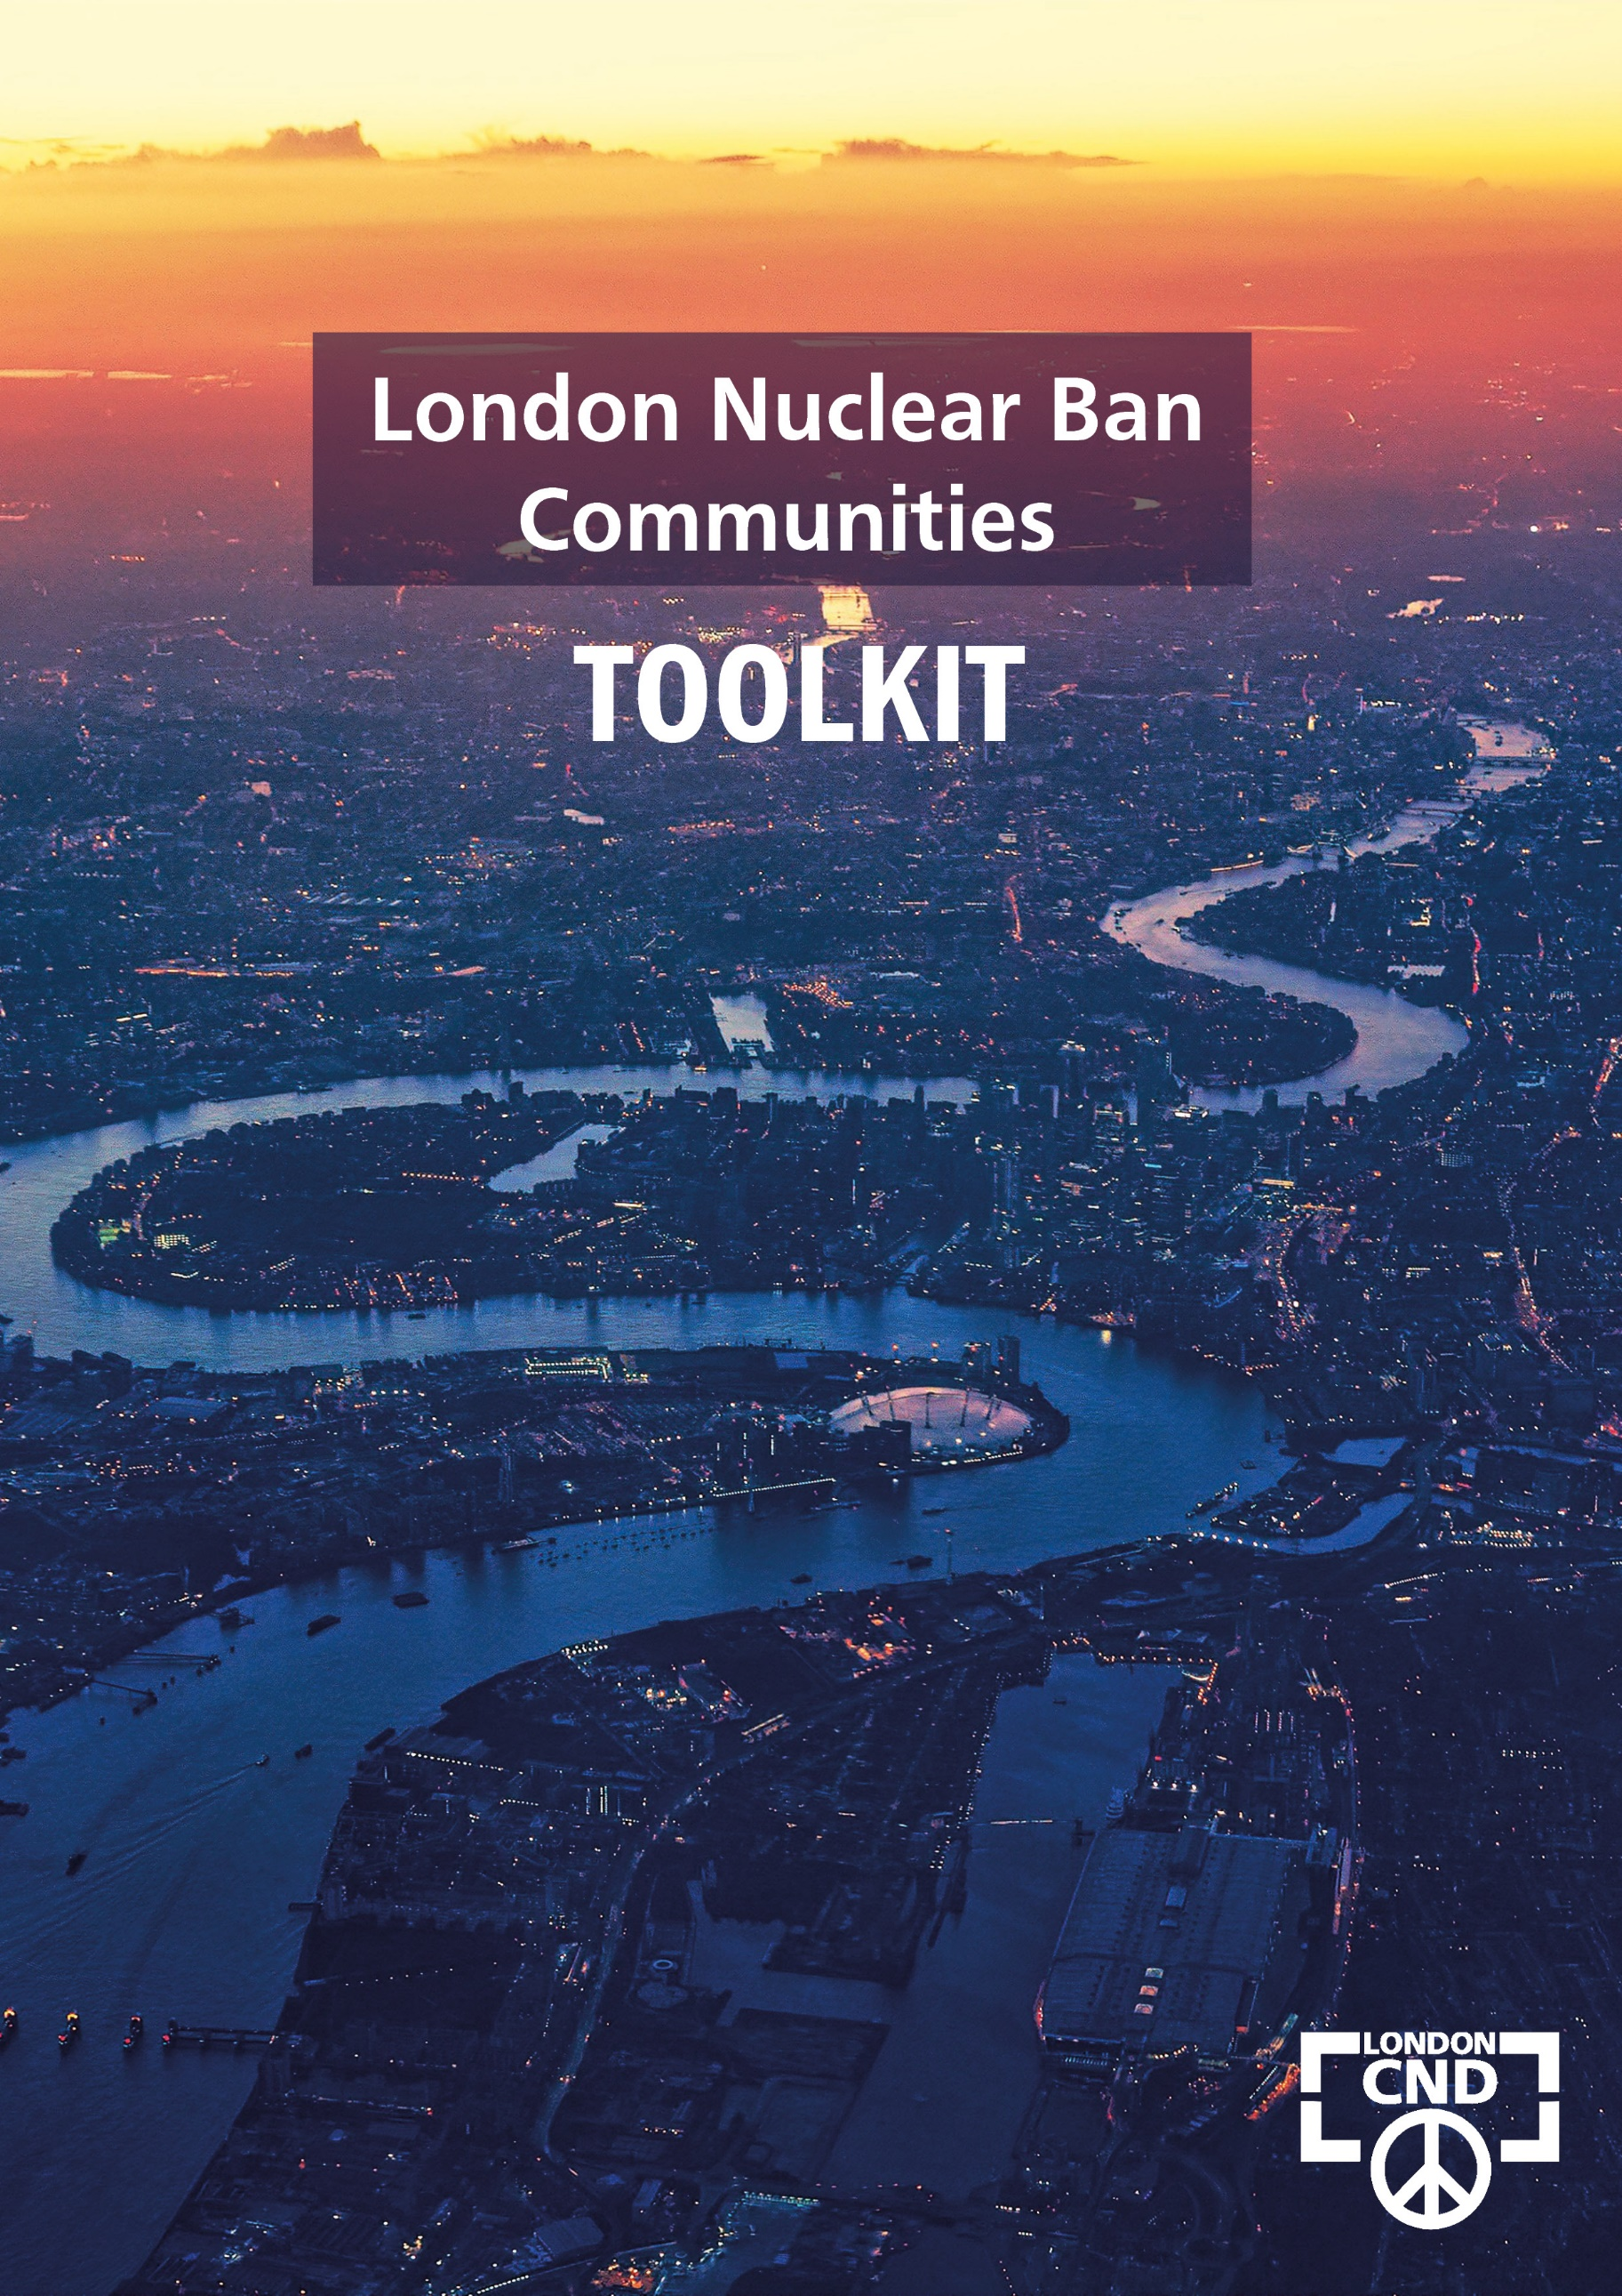
London Nuclear Ban Communities Tool Kit

CONTENTS
Appeal by Emma Dent-Coad page 1

The Treaty on the Prohibition of Nuclear Weapons page 2
A world without nuclear weapons
The Treaty and its signatories
More about CND’s campaign

London Nuclear Ban Communities Pledge page 4

London Tool Kit page 5
The London Pledge

Tools for local campaigning
- Emma Dent-Coad appeal
- Draft letter(s) to the press
- Model motions and accompanying letters:
London Borough Councils, Majority Groups, Councillors
Local organisations
Local Labour Parties
Religious leaders

LONDON REGION
Campaign for Nuclear Disarmament

162 Holloway Rd □ London □ N7 8DQ Email □ info@londoncnd.org

AN APPEAL FROM EMMA DENT-COAD

Dear Friend,
I’m launching London CND’s Nuclear Ban Communities initiative to coincide with the Treaty on the Prohibition of Nuclear Weapons (TPNW) becoming international law on 22 January 2021, and I’d like to tell you about it.
There are international laws banning landmines and chemical and biological weapons, but nuclear weapons remained legal – until now, that is. The TPNW has the support of 122 UN member states.
The big obstacle for those of us in Britain campaigning for a nuclear weapons-free world is that the Tory government has said it will never sign. It has committed to spending £205 billion to upgrade Trident, the UK’s nuclear weapons system, prioritising the development of a weapon of mass and indiscriminate destruction over tackling poverty and ill health.
I’m a former MP and a councillor in Kensington and Chelsea. It’s one of the richest places in Britain, with some of the poorest people in the country. The Grenfell Tower fire happened at the end of my road. Believe me, I know all about poor spending priorities.
World opinion on nuclear weapons is changing. There are clear signs that more people in Britain are finding the prospect of nuclear arms repellent. A Survation poll commissioned by CND and conducted on 12-13 January 2021 found:
- 59% of the public think the UK government should sign up to the TPNW outlawing nuclear weapons
- 77% support a ‘total ban on all nuclear weapons globally’
- 71% of Conservative voters and 83% of Labour voters support a global ban, and
- both the UK signing the TPNW and a total global nuclear ban have majority support across every single demographic – age, regions and nations, education level, income bracket.

CND has a plan to challenge the government, and groups across the country have already started working to make that happen.
Over the next few months, I will be approaching leading figures in London – council leaders, mayors and MPs, faith leaders, well-known names from the arts and entertainments – asking them to sign the nuclear-weapons free pledge.
It a big job, and it can’t happen without your support. I’m asking you support our campaign and work in your community to build support for making Britain nuclear-weapons free.
London CND has prepared a toolkit to help you get involved. I’m holding a working meeting on Monday 1 February to kick us all off, and hope to organise others from time to time, to report back on our successes and challenges.
Let's make London a Nuclear Ban Community – starting with you.
Yours in peace,
Emma Dent-Coad
THE TREATY
ON THE PROHIBITION OF NUCLEAR WEAPONS

A world without nuclear weapons

In 2017, and after much discussion, the United Nations adopted a historic international treaty banning nuclear weapons, with 122 countries voting in favour.
Nine countries have nuclear weapons. Almost 200 do not. In fact, 115 countries are already part of nuclear weapons-free zones which cover Southeast Asia, Central Asia, the South Pacific, Latin America and the Caribbean and Africa.
The Treaty on the Prohibition of Nuclear Weapons (TPNW) opened for signature in September 2017 and came into force on 22 January 2021, after 50 states had ratified it. More states continue to sign and ratify the TPNW.
The Treaty makes it illegal under international law to develop, test, produce, manufacture, acquire, possess, stockpile, transfer, use or threaten to use nuclear weapons. It also makes it illegal to assist or encourage anyone to engage in these activities.
The UK government refused to participate in the TNPW. When it was agreed by the UN, Britain issued a statement attacking the treaty. The Nuclear Ban Communities initiative is ongoing across the UK. Community by community, we are bringing the pressure of public opinion to bear to change the government’s mind.

The Treaty and its signatories

Text of treaty
https://treaties.un.org/doc/Treaties/2017/07/20170707%2003-42%20PM/Ch_XXVI_9.pdf

Treaty signatories and ratifications
https://treaties.un.org/pages/ViewDetails.aspx?src=TREATY&mtdsg_no=XXVI-9&chapter=26

More about CND’s campaign

CND Briefing on what the TPNW means for the UK
https://tinyurl.com/y3jcuusa

Visit CND UK website for updates on the Nuclear Ban Communities campaign across Britain
https://cnduk.org/

Sign up to London CND’s e-news updates for what’s happening in the capital
info@londoncnd.org

LONDON NUCLEAR BAN COMMUNITIES PLEDGE
Please help to collect signatures from as many organisations and individuals in your locality as you can. Here’s the Pledge we’re asking them to sign:

The London Pledge
[We are / I am] deeply concerned about the grave threat that nuclear weapons pose to communities throughout the world.
[We / I] firmly believe that all people have the right to live in a world free from this threat.
Any use of nuclear weapons, whether deliberate or accidental, would have catastrophic, far-reaching and long-lasting consequences for people and the environment.
Therefore, [we / I] support the Treaty on the Prohibition of Nuclear Weapons and call on the UK government to sign and ratify it.

Name ………………………………………………………………………..

Organisation ………………………………………………………………………..

Position ………………………………………………………………………..

Contact ………………………………………………………………………..
please give your email, mobile or postal address

SIGNED ………………………………………………………………………..

Date ………………………………………………………………………..

THE LONDON TOOL KIT

Appeal by Emma Dent-Coad see page 1

Emma’s personal appeal can be sent to groups and individuals you are approaching. You’ll find it on page 2 of this Tool Kit

Model letters to your local press forthcoming

- We’re launching the Nuclear Ban Communities campaign in our locality

- We have written to the Mayor / Council / local MP asking them to sign

- We are delighted that [list] have signed the pledge

London Borough Councils
Approaching your local council should be fine-tuned to the circumstances. If there is no overall majority for example, each political party should be contacted separately. Every political party will have an official caucus of their councillors. If your LB Council has a Conservative majority and you might fear they will be unresponsive to putting demands on their own government, you could write to Labour, LibDem, and/or Green groups, asking them to raise it.
You might also consider writing to individual councillors asking them to sign the Pledge and approaching political party organisations to support the Pledge and raise it with their council / group.

MODEL MOTION
for London Borough Councils / Ruling Groups LB Councils

This [London Borough of NAME] believes that all people should have the right to live free from the fear of nuclear annihilation.

We declare our support for the international Treaty on the Prohibition of Nuclear Weapons (TPNW) which became international law on 22 February 2021, providing for the complete prohibition on developing, testing, and using nuclear weapons, and assist others to use or threaten to use them.

In adopting this resolution, the LB of [NAME] declares its support for the global abolition of nuclear weapons. We call on the government of the United Kingdom to sign and ratify the Treaty on the Prohibition of Nuclear Weapons.

COVERING LETTER
for Mayors and Council Leaders, for adapting for official party groups on council

Dear [NAME ]
[I / We] write on behalf of the London Nuclear Ban Communities initiative to ask your Council to support our efforts to encourage London to join the growing ranks of cities across the world supporting a global ban on nuclear weapons. Towns and cities around the world are pledging their support the TPNW.
[I am / We are] part of a campaign taking place across Britain to persuade the UK government to sign and ratify the Treaty on the Prohibition of Nuclear Weapons (TPNW) which passed into international law on 22 January 2020. You can find out more about UK towns and cities supporting this initiative at https://cnduk.org/nuclear-ban-communities/
A recent Survation poll commissioned by the Campaign for Nuclear Disarmament to coincide with the TPNW becoming law, showed 59% of the public support the UK government signing up to the Treaty, including 50% of Conservative voters and 68% of Labour voters.
[I / We] enclose:
- an appeal for support from Emma Dent-Coad, who is leading the campaign in London,
- The London Nuclear Ban Communities Pledge, and
- a model motion for your consideration.
[I /We] would be pleased to discuss this initiative further with you and/or let you have more information about the Treaty and the campaign. Please get in touch [contact details]
Yours in peace,
Political Parties
It’s well worth approaching local branches of political parties to join the London NBC campaign. Each political party organises differently, and letters and motions should be drafted to take account of this. It may get more attention, for example, if a member of the local party circulates the motion – but don’t be deterred from contacting the party yourselves if need be.

MODEL MOTION
for local Labour Parties
This [NAME Branch / Constituency LABOUR PARTY] believes that all people should have the right to live free from the fear of nuclear annihilation.
We support for the international Treaty on the Prohibition of Nuclear Weapons (TPNW) which became international law on 22 February 2021, and provides for the complete prohibition on developing, testing, and using nuclear weapons, and assist others to use or threaten to use them.
We note the results of a recent Survation poll commissioned by the Campaign for Nuclear Disarmament which showed:
- 77% of the public support a ‘total ban on all nuclear weapons globally’, including 83% of Labour voters and 71% of Conservative;
- 59% think the UK government should sign up to the TPNW outlawing nuclear weapons; and
- these results have majority support across every single demographic – age, regions and nations, education level, income bracket.

We call on:
the [LB NAME / LB Labour Group] to sign the London Nuclear Communities Pledge in support of the global abolition of nuclear weapons,
our Labour MP [NAME] to sign the Pledge, and
the Labour Party leadership to commit to signing and ratifying the TPNW when in government.

COVERING LETTER

Dear [NAME ]
[I / We] write on behalf of the London Nuclear Ban Communities initiative to ask if our local Labour Party will consider supporting our efforts to encourage London to join the growing ranks of towns and cities in Britain and across the world pledging their support for a global ban on nuclear weapons.
[I am / We are] part of a campaign taking place across Britain to persuade the UK government to sign and ratify the Treaty on the Prohibition of Nuclear Weapons (TPNW) which passed into international law on 22 January 2020. You can find out more about UK towns and cities supporting this initiative at https://cnduk.org/nuclear-ban-communities/
We’d like to draw your attention to a recent Survation poll which showed that a majority of the British public support a global ban on nuclear weapons and believe the UK government should sign the Treaty, including a large majority of Labour voters.
[I / We] enclose:
- an appeal for support from Emma Dent-Coad, who is leading the campaign in London,
- The London Nuclear Ban Communities Pledge, and
- a model motion for your consideration.
[I /We] would be pleased to discuss this initiative further with you and/or let you have more information about the Treaty and the campaign. Please get in touch [contact details]
Yours in peace,
Community Organisations

MODEL MOTION
for community organisations

This [NAME OF ORGANISATION] believes that all people should have the right to live free from the fear of nuclear annihilation.

We declare our support for the international Treaty on the Prohibition of Nuclear Weapons (TPNW) which became international law on 22 February 2021, providing for the complete prohibition on developing, testing, and using nuclear weapons, and assist others to use or threaten to use them.

We agree to:

In adopting this resolution, we declare our support for the global abolition of nuclear weapons, and agree to take the following steps on behalf of [NAME OF ORGANISATION]:

- sign the London Nuclear Ban Communities Pledge,
- make public our commitment for the TPNW and urge others to join us;
- call on the London Borough of [LOCAL AUTHORITY NAME] to do likewise; and
- write to Prime Minister Boris Johnson urging the UK government to sign and ratify the Treaty on the Prohibition of Nuclear Weapons.

COVERING LETTER

Dear Friends,

[I / We] write on behalf of the London Nuclear Ban Communities initiative to ask [NAME OF ORGANISATION] to support our efforts to persuade London Boroughs and the Greater London Authority to support a global ban on nuclear weapons.

[I am / We are] part of a campaign taking place across Britain to persuade the UK government to sign and ratify the Treaty on the Prohibition of Nuclear Weapons which came into international law on 22 January 2020. Towns and cities around the world are pledging their support the TPNW. You can find out more at https://cities.icanw.org/

A recent Survation poll commissioned by the Campaign for Nuclear Disarmament to coincide with the TPNW becoming law, showed 59% of the public support the UK government signing up to the Treaty, including 50% of Conservative voters and 68% of Labour voters.

[I / We] enclose:
- an appeal for support from Emma Dent-Coad, who is leading the campaign in London,
- The London Nuclear Ban Communities Pledge, and
- a model motion to consider submitting to your local organisation.

[I /We] would be pleased to discuss this initiative further with you and/or let you have more information about the Treaty and the campaign. Please get in touch [contact details]

Yours in peace,

Religious leaders

COVERING LETTER

Dear [NAME ]
[I / We] write to seek your support for the London Nuclear Ban Communities initiative, which encourages London to join the growing ranks of cities pledging their support for a global ban on nuclear weapons internationally.
The London Campaign for Nuclear Disarmament is part of a peace campaign taking place across Britain to persuade the UK government to sign and ratify the Treaty on the Prohibition of Nuclear Weapons (TPNW) which passed into international law on 22 January 2021.
Nuclear weapons are capable of murdering millions of innocent people by the press of a button. There is no faith on earth which would support such a position, and the leaders and members of all the major faiths have opposed nuclear weapons since their invention. People of faith have hope for a better world where we can be rid of this threat.
[I / We] enclose:
- an appeal for support from Emma Dent-Coad, who is leading the campaign in London,
- The London Nuclear Ban Communities Pledge, which can also be signed directly on our website: https://www.londoncnd.org/sign-the-pledge
[I /We] would be pleased to discuss this initiative further with you and/or let you have more information about the Treaty and the campaign. Please get in touch [contact details]
Yours in peace,

Links:
- For Christian leaders, link Christian CND’s page on the Biblical case against nuclear weapons https://christiancnd.org.uk/the-biblical-case-against-nuclear-weapons/
- For leaders of other faiths, link Religions for Peace (https://www.rfp.org/)

More model motions, accompanying letters and other campaigning aids will be added to London CND’s Tool Kit in the weeks to come……

